English Semillero
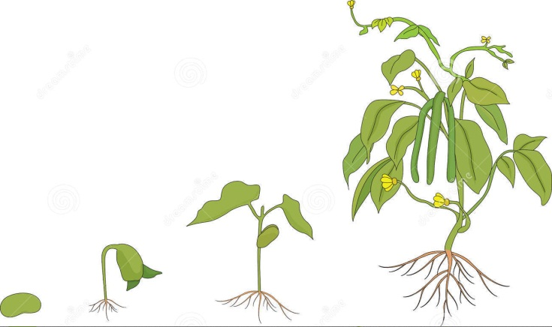

COURSE:
http://www.ompersonal.com.ar/omkids/presentacion.htm OMKIDS

PLAYS
http://www.starfall.com/n/plays/dog-and-cat/load.htm?f PLAY cat and dogs
http://www.angles365.com/classroom/stories/twostupid/twostupid.swf PLAY AND CHANTS : TWO STUPID CATS

STORIES:
http://www.angles365.com/classroom/stories2/mouse.swf I SEE AN ANT
http://www.angles365.com/classroom/stories/giant/giant.swf THE GIANT AND THE BOY
http://www.angles365.com/classroom/stories/whereisbone/whereisbone.swf WHERE IS MY DOG? CHANT

